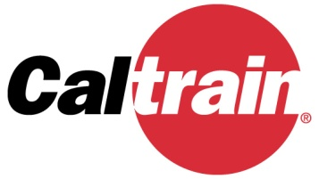

Notice of Cancellation

Caltrain Local Policy Maker Group (LPMG) Meeting

The Caltrain LPMG meeting for Thursday, July 28, 2022
has been cancelled.

The next scheduled meeting is Thursday, August 25, 2022.

